Light and sound
Define these words

- Transparent
………………………………………………………………………………………………………………………………………………………………………………………………………………………………………………………………………………………………………
- Translucent
………………………………………………………………………………………………………………………………………………………………………………………………………………………………………………………………………………………………………
- Opaque
……………………………………………………………………………………………………………………………………………………………………………………………………………………………………………………………………………………………………….
- Luminous
………………………………………………………………………………………………………………………………………………………………………………………………………………………………………………………………………………………………………
- Non-luminous
……………………………………………………………………………………………………………………………………………………………………………………………………………………………………………………………………………………………………….
- Reflection
………………………………………………………………………………………………………………………………………………………………………………………………………………………………………………………………………………………………………

- Refraction
………………………………………………………………………………………………………………………………………………………………………………………………………………………………………………………………………………………………………
- Dispersion
………………………………………………………………………………………………………………………………………………………………………………………………………………………………………………………………………………………………………
- Spectrum
………………………………………………………………………………………………………………………………………………………………………………………………………………………………………………………………………………………………………..
- Pitch
………………………………………………………………………………………………………………………………………………………………………………………………………………………………………………………………………………………………………
- Frequency
……………………………………………………………………………………………………………………………………………………………………………………………………………………………………………………………………………………………………….
- Wavelength
……………………………………………………………………………………………………………………………………………………………………………………………………………………………………………………………………………………………………….
- Decibels
………………………………………………………………………………………………………………………………………………………………………………………………………………………………………………………………………………………………………..

Use the listed words to complete the sentences.
convex | focal | frequency | microwaves | opaque
plane | rays | reflection | scattered | speed
straight | translucent | transparent | transverse
1. Light is a form of energy. Light travels in ………………. lines. The lines that are used to show the path of light are called ……………….
2. Light travels at the ………………. of 300 000 kilometres per second in a vacuum.
3. Rays or beams of light may be seen when light is ………………. or reflected from particles in substances and redirected to the eye.
4. Light reflected from a mirror follows the law of ………………. which states: the angle of incidence equals the angle of reflection. Flat mirrors are called ………………. mirrors.
5. Curved mirrors may be concave (curved inwards) or ………………. (curved outwards). Light reflected from concave and convex mirrors also follows the law of reflection. Parallel rays of light are reflected to a ………………. point in a concave mirror. Convex mirrors reflect light from a wide angle creating an image reduced in size that captures much of the surrounds.
6. Shiny surfaces reflect light but if a surface absorbs light it is said to be ……………….
7. If most of the light travels through a material, the material is said to be ………………. For example, window glass.
8. Some materials allow some light to travel through but also scatter some of the light. Objects are not clearly visible when viewed through these materials. Frosty glass used in bathroom windows is an example. Such materials are said to be ……………….

9.
Complete the table below giving examples of materials that are;
Transparent | Translucent | Opaque

- Use the terms below to identify the lenses and mirrors shown.

Concave mirror | Convex mirror | Converging lens | Diverging lens

- (ii)
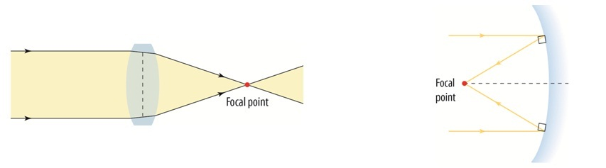
...................................................... ......................................................

(iii) (iv)
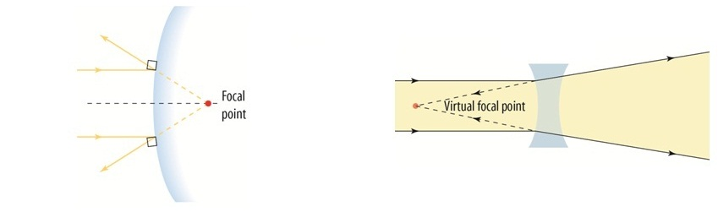
...................................................... ......................................................

- Which of the mirrors or lenses above would you use as a magnifying glass?
....................................................................

- Which of the mirrors or lenses above would you find being used at an intersection so that drivers can see around a blind corner?
....................................................................
- For each of the diagrams below, draw the path of the light beams that would result.
(a) (b)
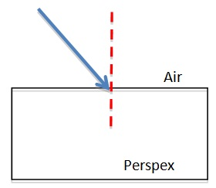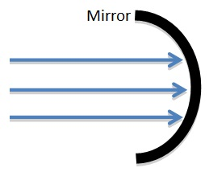

(a) Identify each of the structures labeled U–Z in the diagram of the eye below.
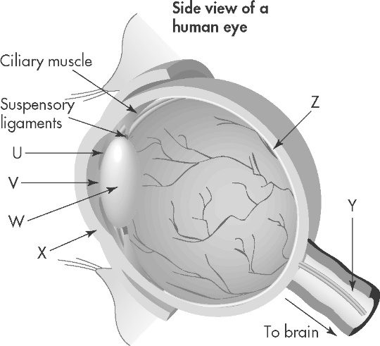 | U: .......................................................  V: ........................................................  W: .......................................................  X: ........................................................  Y: ........................................................  Z: .........................................................
(b) Identify the structure of the eye that matches each of the following descriptions:
A. Bends the incoming light, so that it passes through the pupil towards the lens.
B. The image forms here. The light-sensitive cells detect the brightness and colour of the different parts of the image.
C. The opening through which light travels towards the lens.
A: | B: | C:

- Examine the following diagram of a wave.
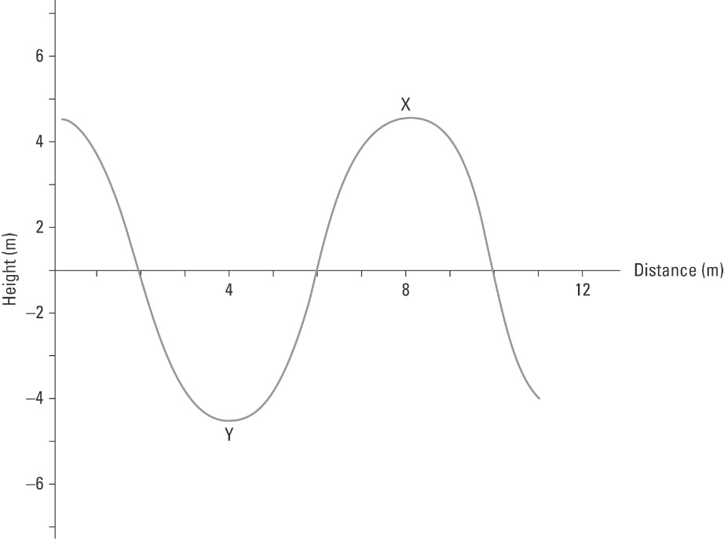
(a) Identify the type of wave illustrated.
(b) Two parts of the wave are labelled X and Y. Name these parts.
X: ..................................................................... Y: .....................................................................
(c) Use the scale to determine the wavelength and amplitude of the wave.
Wavelength: ............................................................
Amplitude: ..............................................................

- Insert the following words into the diagram of the auditory system below.

Cochlea | Eustachian tube | Ear drum
Auricle | Auditory nerve | Ear canal


